**Project Design Phase-II**

**Technology Stack (Architecture & Stack)**

|  |  |
| --- | --- |
| Date | 03 October 2022 |
| Team ID | PNT2022TMID34081  **Explore AS, differentiate**  **Deﬁne CS, ﬁt into CC** |
| Project Name | Deep learning Fundus image Analysis for Early Detection of  diabetic Retinopathy |
| Maximum Marks | 4 Marks |

**Technical Architecture:**

The Deliverable shall include the architectural diagram as below and the information as per the table1 & table

2 :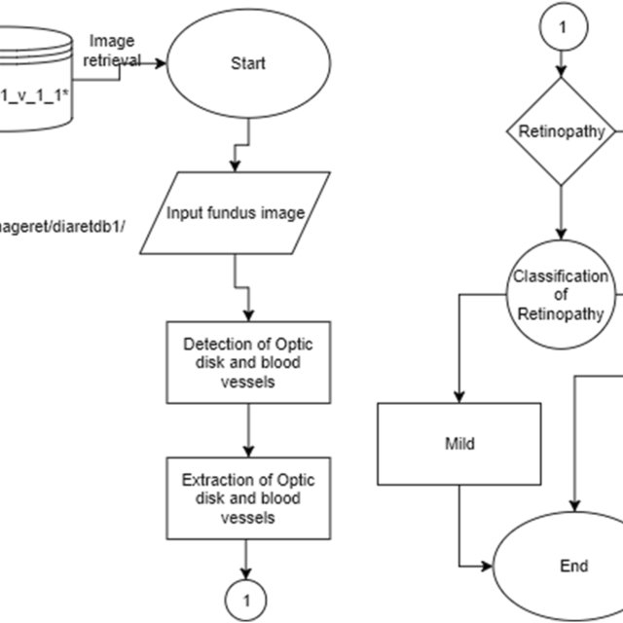

|  |  |  |  |
| --- | --- | --- | --- |
| **S.No** | **Component** | **Description** | **Technology** |
| 1. | User Interface | Graphical User Interface, DR grading System | AI Eye Screening System |
| 2. | Application Logic-1 | The application is based on the Artificial intelligence algorithm | Ai Device |
| 3. | Application Logic-2 | The application includes the Early detection , Edge detection. | Deep learning fundus image Analysis. |
| 4. | Application Logic-3 | Establishing Optimal Screening intervals Based on Risk Profile. | DR Progression |
| 5. | Database | Indian Diabetic Retinopathy Image Dataset | Screening Research |
| 6. | Cloud Database | Cloud based onboard prediction and diagnosis | IBM Cloudant |
| 7. | External API-1 | Laser treatment usually works very well to prevent vision loss if it’s done before the retina has been severely damaged.  **Explore AS, differentiate**  **Explore AS, differentiate**  **Deﬁne CS, ﬁt into CC** | Laser |
| 8. | External API-2 | Severe proliferative retinopathy may be treated with a more aggressive laser therapy called scatter(pan-retinal)photocoagulation. | Photo Coagulation |
| 9. | Machine Learning Model | This indicates the advanced machine learning algorithms  Such as SVM and ANN perform better than the other | Early Detection. |
| 10. | Infrastructure | Availability of eye care infrastructure and human resources  **D eﬁne CS, ﬁt into CC** | Deep learning |

**Table-2: Application Characteristics:**

|  |  |  |  |
| --- | --- | --- | --- |
| **S.No** | **Characteristics** | **Description** | **Technology** |
| 1. | Open-Source Frameworks | Deep learning | Deep Learning using fundus image analysis for early detection. |
| 2. | Security Implementations | Improved Automated Detection. | Encryptions. |
| 3. | Scalable Architecture | Multimodal Deeplearning Architecture with Retinal Lesion | Convolutional Neural Network |
| **S.No** | **Characteristics** | **Description** | **Technology** |
| 4. | Availability | IBM developed a method combining deep learning and visual analytics. | Computer aided diagnosis |
| 5. | Performance | It takes a long time to diagnosis and may require many eye exams.Early detection of DR may prevent or delay the vision loss. | Evaluation of Artificial Intelligence Assisted  Diabetic Retinopathy |